Logo

Class vii

Lab 24

**Lab Objectives:**

* Making a logo for your company

What is logo?

a symbol or other small design adopted by an organization to identify its products, uniform, vehicles, etc.



Logo for Your Company

Previously you have designed a burger poster for your burger shop. Selling that burger with buy one get one offer was your main concern. But you haven’t used your company name there. Today you will do that’s task.

Suppose you are the owner of a burger shop which name is “Burger Hub”. You want to make a logo of that so that you can put that logo on your burger’s “Buy One Get One Offer” poster.

You will create a logo like this.

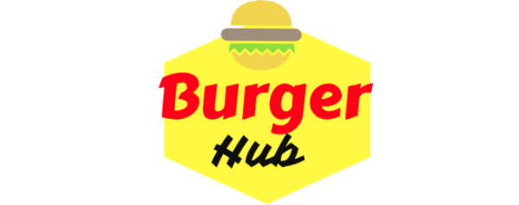

Look at this logo, it has a transparent background. That means there are no other colors or images behind the pictures. These transparent images are saved in “png” format so that you can easily set it on your poster.

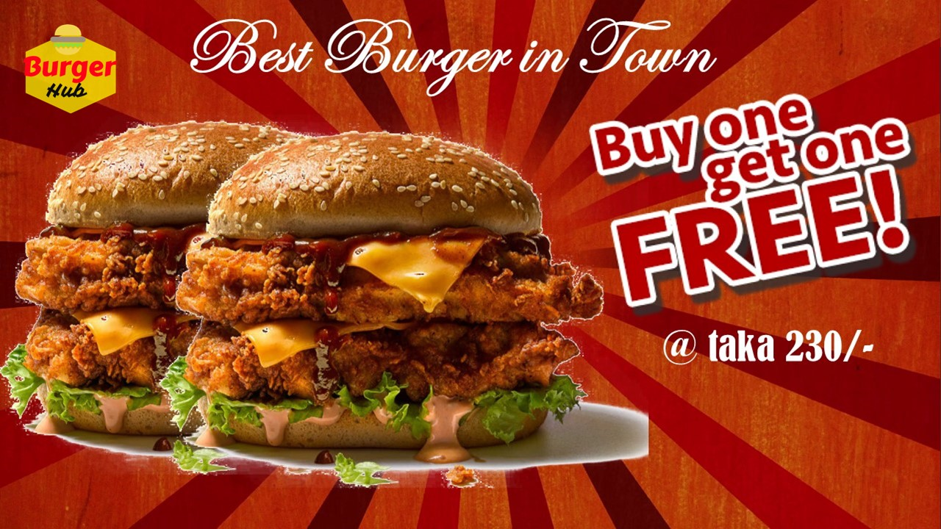You are going to create a poster like this. Have a look your logo is on the left top of your poster.

So let’s get started!

Go to <https://logomakr.com/>

Cross the video suggestion

Click on “next” for every suggestion you get.

Finally you will get an white empty canvas to draw your logo.

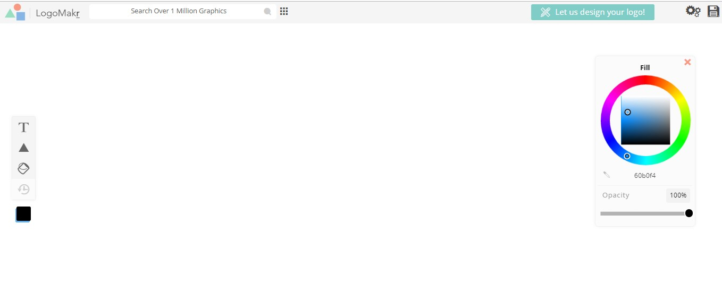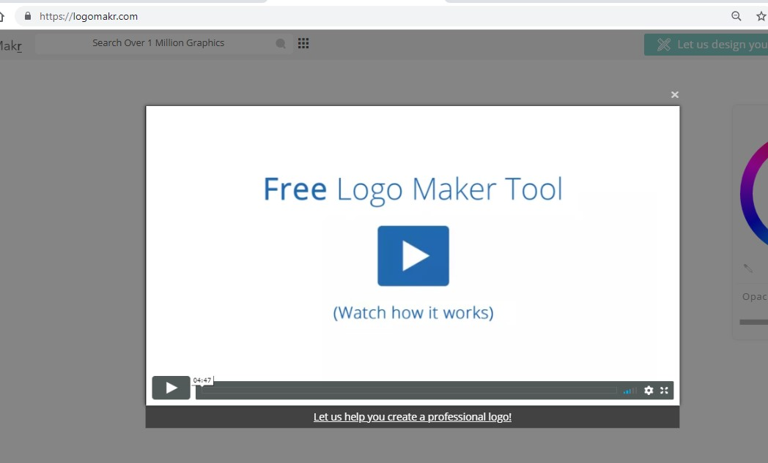

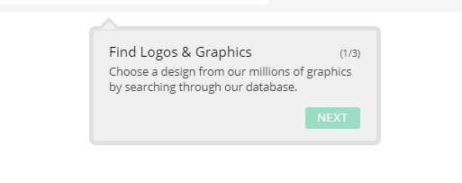

Search burger from search box. Choose one and select. You’ll see it on your canvas.

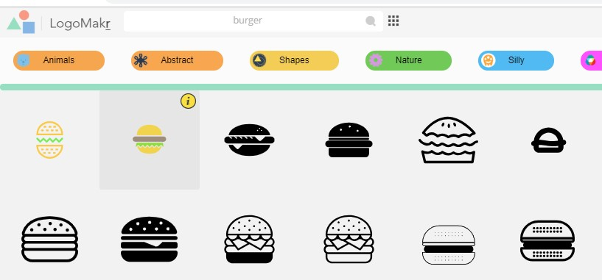

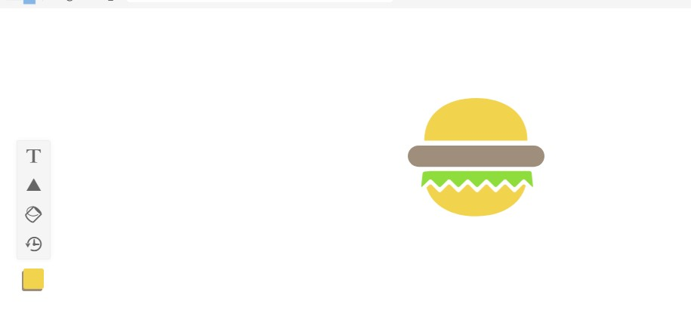

Click text and write burger

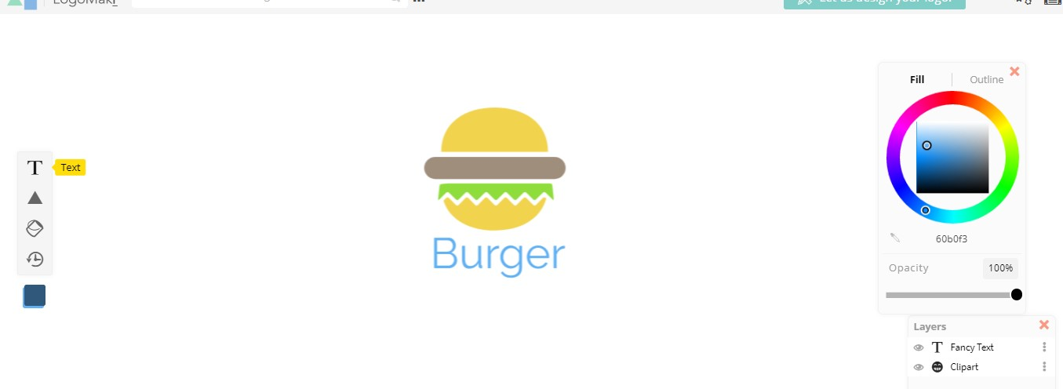

Change the font style. Use font group handwriting and style Carter One.

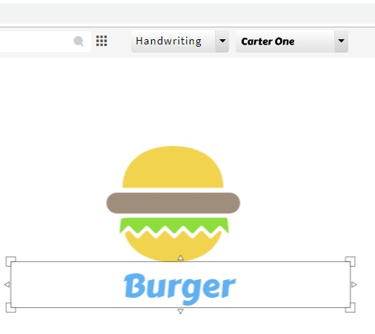

Change the color of the text in red. Move your mouse and pick red color from the color picker.

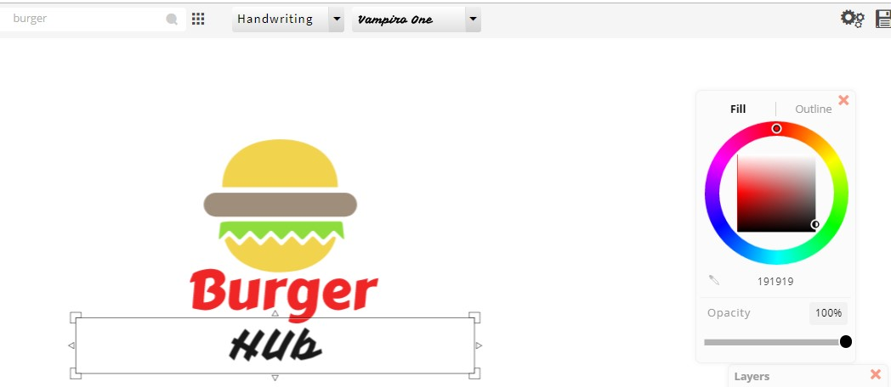Using same process write hub. Change its color to black. Use vampire one font style from Handwriting font group.

Press Ctrl+A to resize it.

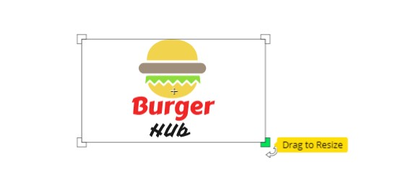

Now take a polygonal shape.

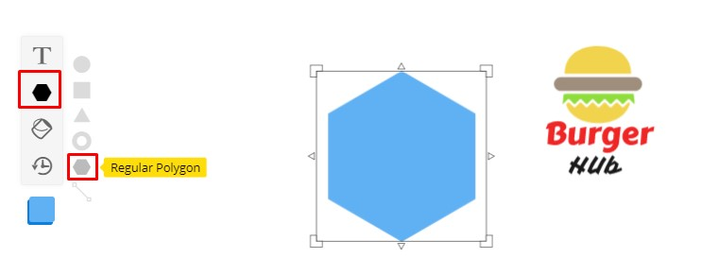

Color this to yellow and drag it upon the burger hub logo.



Write click on the shape and click send to back

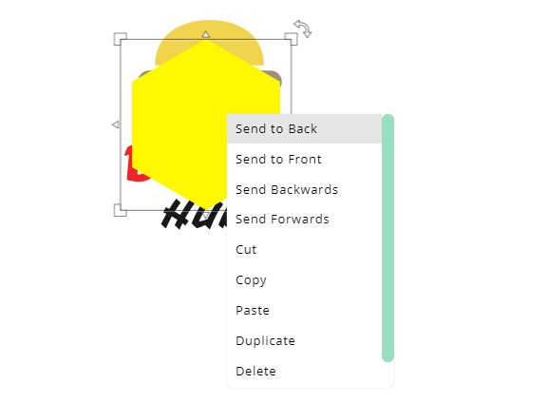

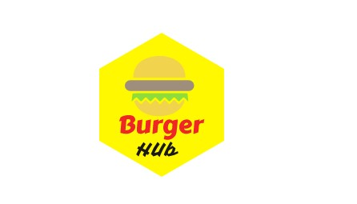Shape will be set for background. Now resize the shape

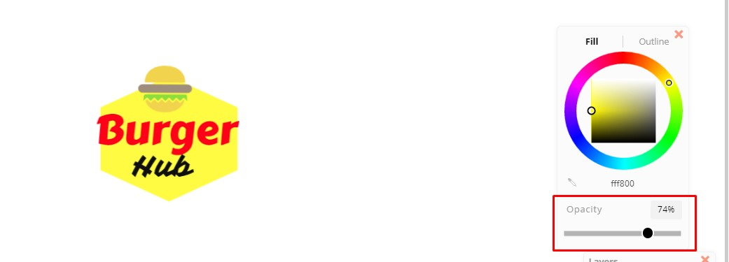After resizing you will get this one. We have minimized the opacity to decrease the brightness of background yellow color

Write click on the canvas and make transparent background

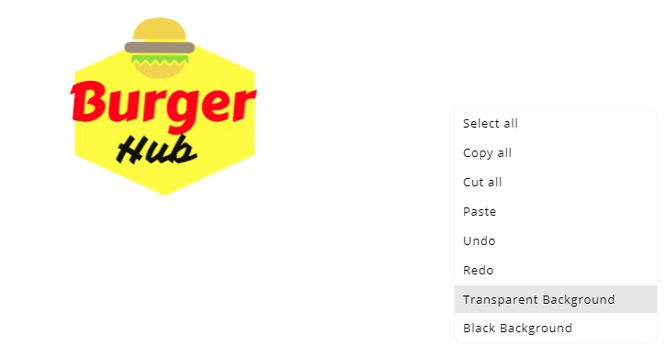

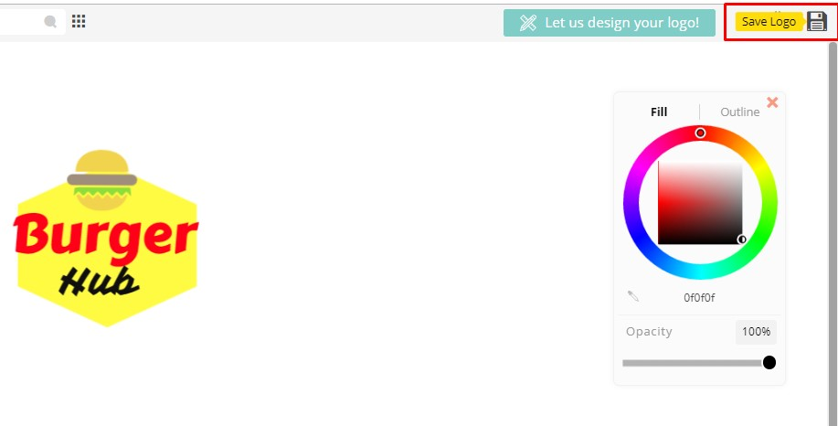Now click to save logo

Click download low resolution file

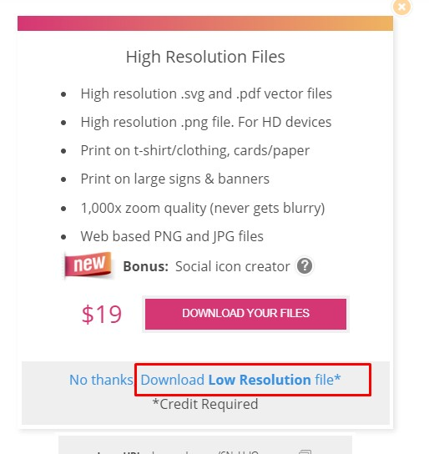

File will be downloaded to your computer.

Open your burger poster and insert your logo and set it to your poster’s top left position and export as JPEG format image.

Here we go!